Name : Marco Ehab
Section : 5

Quiz 1 20/2/2020
In the Hypothetical Machine the contents of memory was as shown. And PC contents is 300. Show the contents of memory and PC , AC , IR after execute three instructions (three fetch cycle and there execute cycle)

ANSWER:-
First Instruction:
•

Fetching:
AC:
0000
IR:
1940
PC:
300
940:
0003
941:
0002
•

Execution:
AC:
0003
IR:
1940
PC:
300
940:
0003
941:
0002
Second Instruction:
•

Fetching:
AC:
0003
IR:
5941
PC:
301
940:
0003
941:
0002
•

Execution:
AC:
0005
IR:
5941
PC:
301
940:
0003
941:
0002
Third Instruction:
•

Fetching:
AC:
0005
IR:
2941
PC:
302
940:
0003
941:
0002
•

Execution:
Ac:
0000
IR:
2941
PC:
302
940:
0003
941:
0005

:-

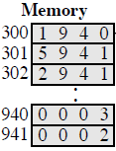

Show the contents of PC , AC and IR and memory after the
execution
of
each
instruction
of
the
following
program
on
the
Hypothetical Machine:
300 LOAD 550
301 ADD 551
302 STORE 600

the contents of memory at 550 is 3 and at 551 is 4

Where
.

ANSWER:-
First Instruction:
•

Fetching:
AC:
0000
IR:
1550
PC:
300
550:
0003
551:
0004
600:
0000

•

Execution:
AC:
0003
IR:
1550
PC:
300
550:
0003
551:
0004
600:
0000

Second Instruction:
•

Fetching:
AC:
0003
IR:
5551
PC:
301
550:
0003
551:
0004
600:
0000

•

Execution:
AC:
0007
IR:
5551
PC:
301

550:
0003
551:
0004
600:
0000

Third Instruction:
•

Fetching:
AC:
0007
IR:
2600
PC:
302

550:
0003
551:
0004
600:
0000
•

Execution:
AC:
0000
IR:
2600
PC:
302

550:
0003
551:
0004
600:
0007

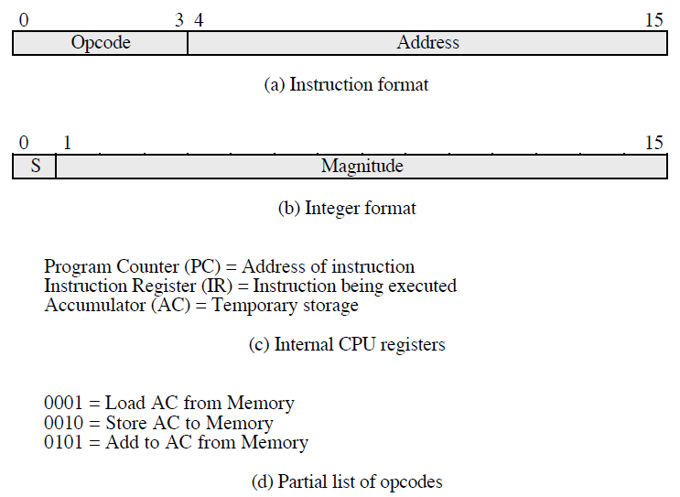

The following figure provide the main characteristics of Hypothetical
Machine
.

The hypothetical machine also has two I/O instructions:

0011 = load AC from I/O

0111 =store AC to I/O

ANSWER:-

In these case, the 12-bi address identifies a particular I/O device.
Show the program execution for the following program:

1. Load AC from device 5.

2. Add contents of memory location 940.

3. Store AC to device 6.

Assume that the next value retrieved from device 5 is 3 and that
location 940 contains a value of 2.

ANSWER:
MEMORY
300
3005

301
5940

302
7006

After executing the three instructions:
device 5:
0003
940:

2
device 6:
0005

